附件

各设区市教育满意度调查二维码

1.南京市：2021-09-24 00:00:00 ~ 2021-09-30 23:59:59
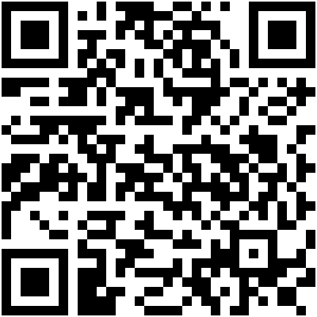
2.盐城市：2021-09-24 00:00:00 ~ 2021-09-30 23:59:59
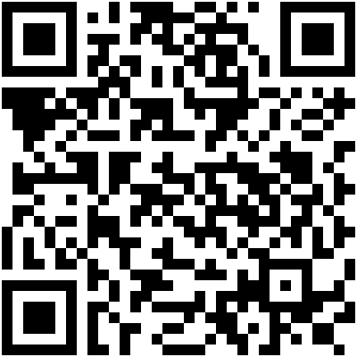

3.镇江市：2021-09-24 00:00:00 ~ 2021-09-30 23:59:59
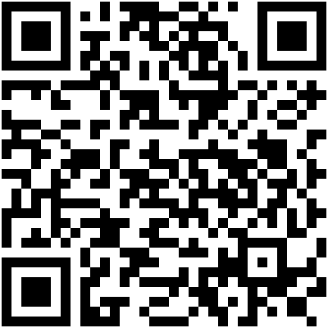
4.宿迁市：2021-09-24 00:00:00 ~ 2021-09-30 23:59:59
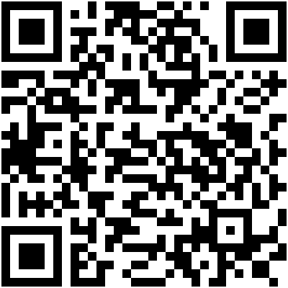
5.无锡市：2021-10-08 00:00:00 ~ 2021-10-14 23:59:59
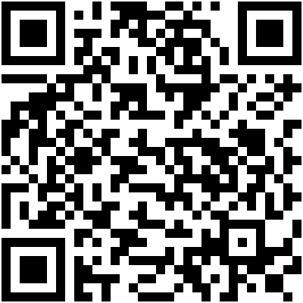
6.徐州市：2021-10-08 00:00:00 ~ 2021-10-14 23:59:59
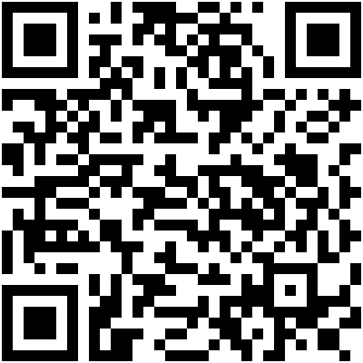
7.连云港市：2021-10-08 00:00:00 ~ 2021-10-14 23:59:59
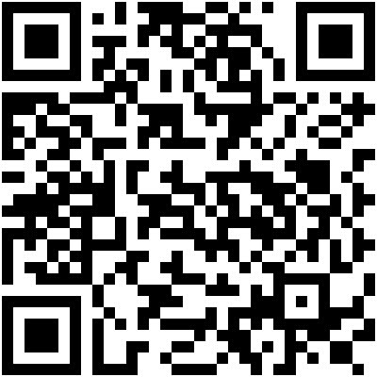
8.淮安市：2021-10-08 00:00:00 ~ 2021-10-14 23:59:59
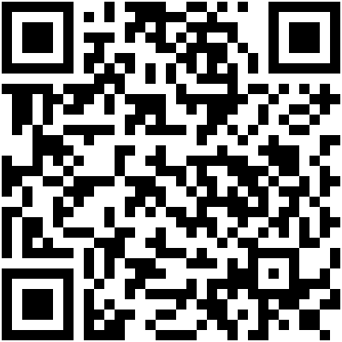

9.常州市:2021-10-15 00:00:00 ~ 2021-10-21 23:59:59
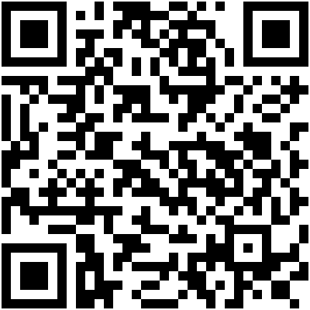
10.苏州市:2021-10-15 00:00:00 ~ 2021-10-21 23:59:59
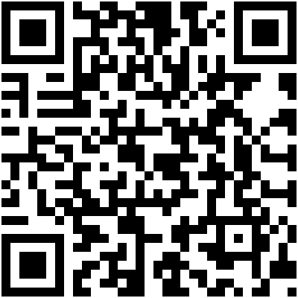
11.南通市:2021-10-15 00:00:00 ~ 2021-10-21 23:59:59
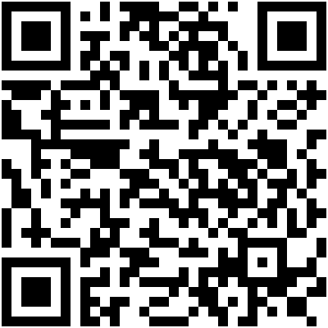

12.扬州市:2021-10-15 00:00:00 ~ 2021-10-21 23:59:59
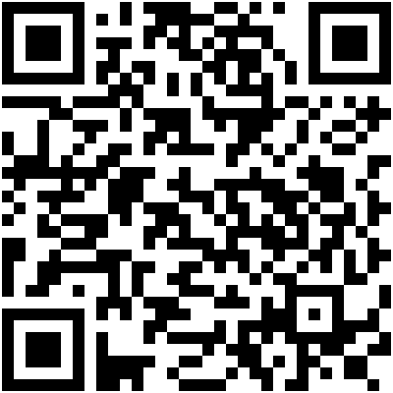
13.泰州市:2021-10-15 00:00:00 ~ 2021-10-21 23:59:59
